G102-1: Applying Properties of Complementary and Supplementary Angles
Useful Vocabulary:
Picture
1.

2.

3.

4.

5.

6.

7.
1.Acute angle: _________________________________________

____________________________________________________.

2.Obtuse angle: ________________________________________

____________________________________________________.

3.Straight angle: _______________________________________

____________________________________________________.

4. Linear Pair: _________________________________________

____________________________________________________.

5.Right Angle: _________________________________________.

6. Complementary angles: ________________________________

____________________________________________________.

7.Supplementary angles: _________________________________

____________________________________________________.

Complementary Angles:
- Always add up to _____.
- Are most often ____________________, or next to, each other, and
make up a _____________________.
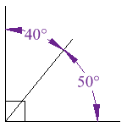

Supplementary Angles:
- Always add up to _______.
- Are most often ___________________, or next to each other, and form a linear pair.
- A ________________________ is two angles that are adjacent, and supplementary.
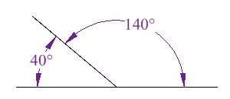
Examples:
1. Given that two angles, ∡ABC and ∡DEF, are
complementary, if m∡DEF is 60, what is the
measure of ∡ABC?

2. Given that two angles, ∡LMN and ∡HOT, are
supplementary, if m∡LMN is 53, what is the
measure of ∡HOT?

3. Based on the following diagram of two adjacent angles that
are complementary, find the value of x, and the measure of
each angle.

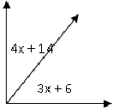

4. Based on the following diagram of two adjacent angles that
are supplementary, find the value of x, and the measure of
each angle.

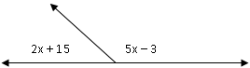

5. Two angles, ∡MAT, and ∡TOP, are supplementary angles. The m∡MAT = x+12, and
the m∡TOP = 6x+7. Find the measures of ∡MAT, and ∡TOP. Explain how you
reached your answer.

6. Two angles,∡MAJ and ∡JAG are complementary. If the m∡MAJ = 4x-12,
m∡JAG= 30°, Find the value of x, and the measure of ∡MAJ. Explain how you
reached your answer.

Try on your own:
Determine if the following statements are true or false. Explain your reasoning.
1. If ∡XYZ and ∡WIN are complementary, then ∡XYZ and ∡WIN are a linear pair.

2. If ∡MAG and ∡SLK are supplementary, then the sum of the measures of these
two angles is 90.

G102-1: Homework
- ∡A is a complement of ∡C. The m∡A=$47°$ . Find the m∡C.

- ∡P is a supplement of ∡R. The m∡R=$36°$. Fine the m∡R.

- In the diagram below ∡ABC, and ∡DBC are complementary angles. Find the m∡ABC, and the m∡DBC.
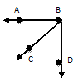
$$13x°$$
$$5x°$$
- In the diagram below ∡CAS, and ∡SAR are supplementary angles. Find the m∡CAS, if the m∡SAR=$140°$.
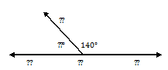
$$S$$
$$x°$$
$$A$$
$$C$$
$$R$$

- ∡1 and ∡2 are supplementary. Suppose that m∡1=$60°$ and m∡2=$(2x+20)°$. What is the value of x?

- 5 b. 10 c. 50 d. 100

G102-1: Homework
- ∡A is a complement of ∡C. The m∡A=$47°$ . Find the m∡C.

- ∡P is a supplement of ∡R. The m∡R=$36°$. Fine the m∡R.

- In the diagram below ∡ABC, and ∡DBC are complementary angles. Find the m∡ABC, and the m∡DBC.
$$13x°$$
$$5x°$$
- In the diagram below ∡CAS, and ∡SAR are supplementary angles. Find the m∡CAS, if the m∡SAR=$140°$.
$$S$$
$$x°$$
$$A$$
$$C$$
$$R$$

- ∡1 and ∡2 are supplementary. Suppose that m∡1=$60°$ and m∡2=$(2x+20)°$. What is the value of x?

- 5 b. 10 c. 50 d. 100

