G102 Review
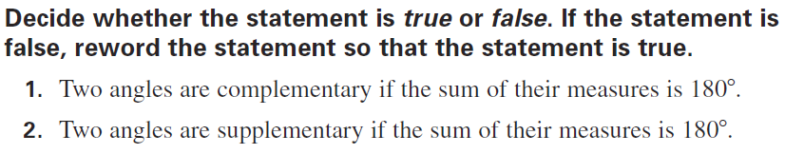

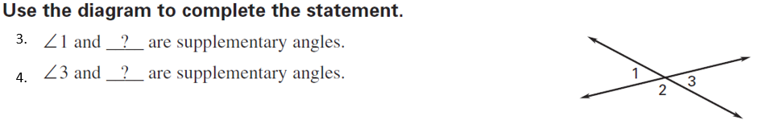
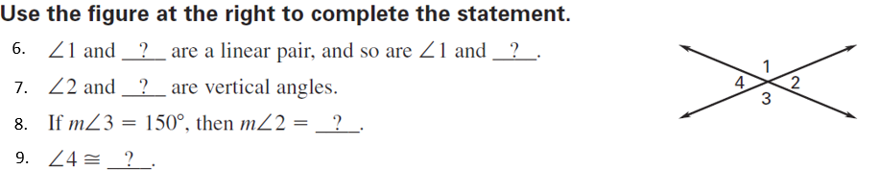
8.
7.
6.
5.

9. a. Draw two lines $\overset{⃡}{MG}$ and $\overset{⃡}{SK}$ intersecting at point $L$.

b. Name a pair of supplementary angles.

c. Name a pair of vertical angles.

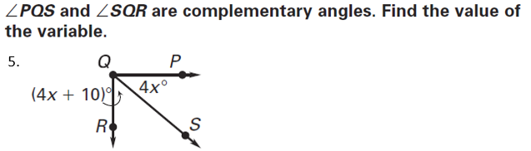
10.

Find the value of the variables:
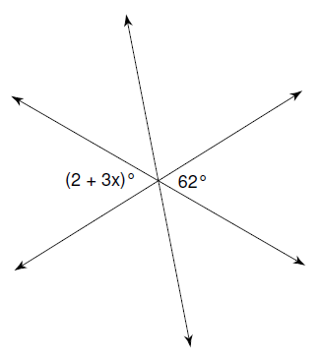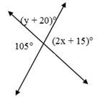
12.
11.

13. $∡ABC$and $∡DEF$are supplementary. $∡ABC=5x-10$ and $∡DEF=4x+28$. Find the value of x and the
measure of each angle.

14. $∡LJH$and $∡TUD$ are complementary. $∡LJH=7m-2$ and $∡TUD=3m+12$. Find the value of m and the
measure of each angle.

Challenge Questions:
15. Is it possible for a pair vertical angles, to also be a linear pair? Explain your reasoning.

16. Is it possible for a pair of vertical angles to be supplementary? Explain your reasoning.

