**G102-2** Vertical Angles

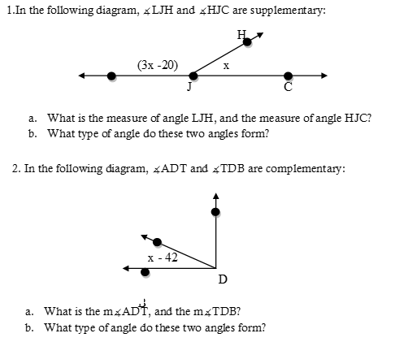

B

T

A

**Useful Vocabulary:**

**Vertical Angles:** ___________________________________________________________________________________________

________________________________________________________________________________________________________.

**Important Facts**

**Picture**

**Properties of Vertical Angles:**

* ______________________________________________
* ______________________________________________
* ______________________________________________

**Examples:**

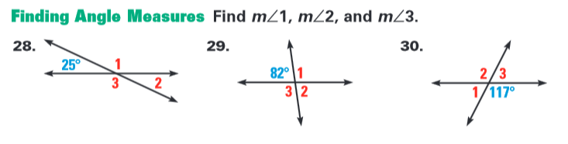

3.

2.

1.

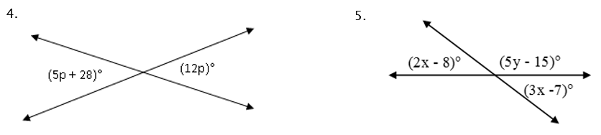

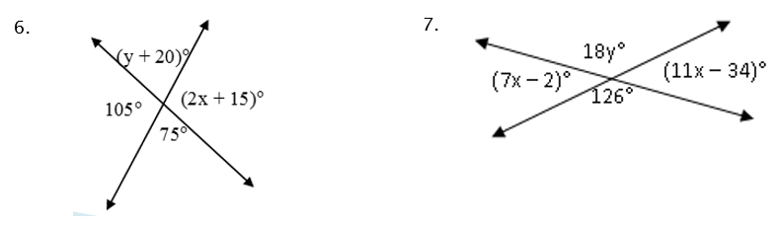

8.





9. The intersecting legs of the draft table below intersect and form four angles. Based on the diagram below, find the measure of the remaining three angles.