**G102-2-Homework:** Vertical Angles

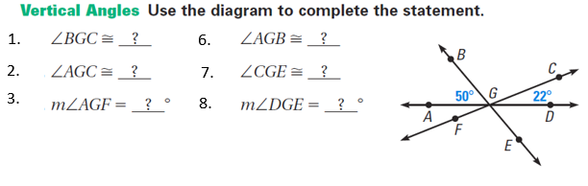

6.

5.

4.

1. Find the value of the variable: 8. Find the value of y:

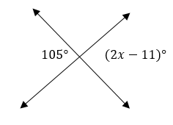 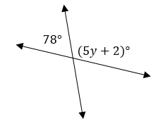

1. Find the value of p.

