**G101-3:** Understanding and Applying the Angle Addition Postulate

**Warm Up:**





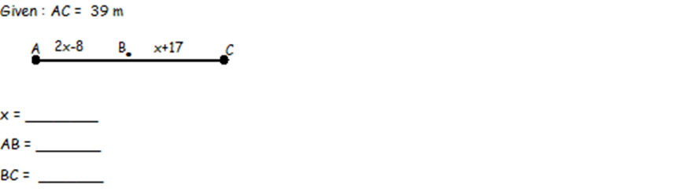

**Angle Addition Postulate:**



_________________________________

**Compare and Contrast:**

Looking back on the Segment Addition Postulate:



If I make one of the smaller angles x, and the other smaller angle y:

m∡AOB = x

m∡BOC = y

m ∡AOC =

$\overline{AB}$ = x

$\overline{BC }$ = y

$\overline{AC}$ =

**What do you notice?**

**Examples:**

1. Draw a ray using the points Q and R.

2. Draw an angle using the points L, M, and N.



3.

4.



5.





6.

**Try on your own:**





2.

**G101-3: Homework**

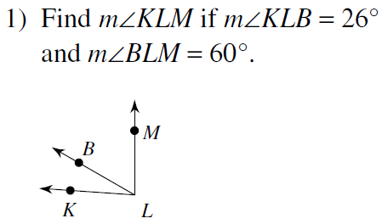 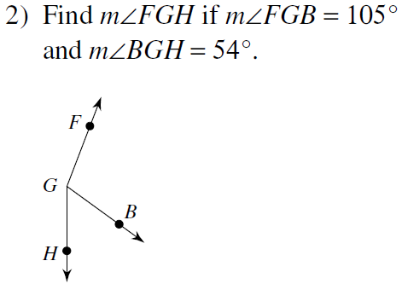

4)

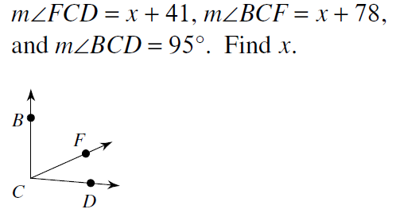 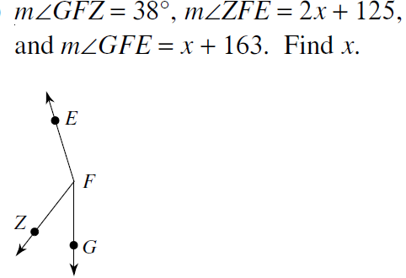

3)

**G101-3: Homework**



 