**G101-2:** Understanding and Applying the Segment Addition Postulate

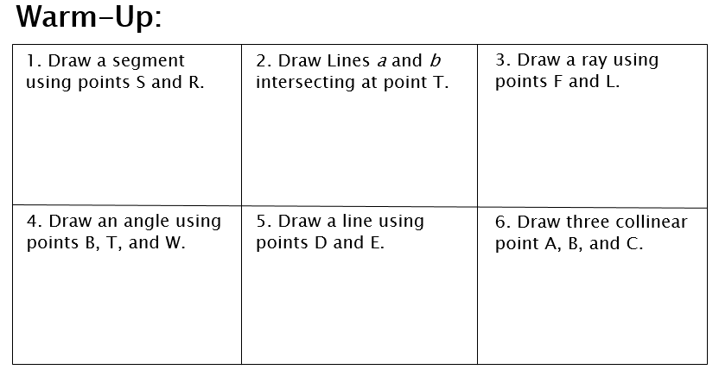

**Discovery:**

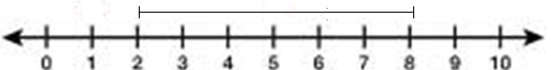

The distance from two to 8 on the number line is ________.

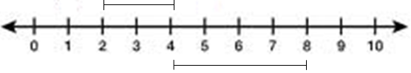

If we break up the distance from 2 to 8 into two parts, 2 to 4 and 4 to 8, when

we add those two separate distances together we get _______.

**Segment Addition Postulate:**

The segment addition postulate states:

If a point B lies on a line segment, AC, then ________________.

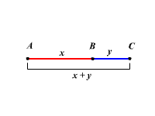

The distance from one endpoint to the other is the ____________________ of the two smaller segments.

**Review of the Distance Formula:**

Another method we can use to find the length of a segment is the distance formula:

____________________________

To use this method we have to be given a set of points.

**Example 1:** Find the length of the line segment, MN, given the endpoints M(1,3) and

N(3,5).

**Example 2:** Point B is in between points A and C. The coordinates of points are as

follows:

A(2,2)

B(8,5)

C(10,6)

1. Find the length of segment AB.
2. Find the length of segment BC.
3. Find the length of segment AC.

**Try on your own:**

1. Draw a sketch of a line segment with three collinear points, x, y, and z. Label the points so that point y is between points x and z. Write the segment addition postulate for these points.
2. Use the following diagram to answer parts a and b. B is the midpoint of segment AC :



1. If the length of segment AC= 16, what is the length of segment BC?
2. If the length of segment AB =4, what is the length of segment AC?
3. If the length of segment AB is 12, and the length of segment BC is 7, find the length of segment AC.



**More Examples:**

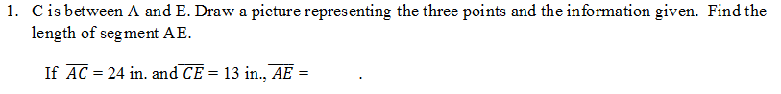

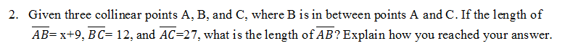

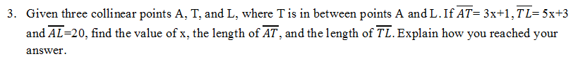

**Try on your own:**

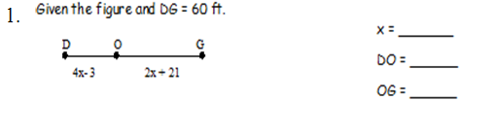

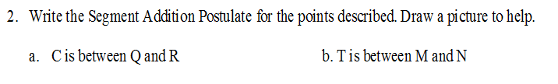

**G101: Mixed Practice**

1. Find the length of PR:

7

9

P

R

Q

1. Find the length of JK

23

17

K

J

L

1. Using the diagram below:

17

$$z+4$$

$$z-3$$

N

M

L

1. Find the value of z.
2. Find the measure of LM.
3. Find the measure of MN.
4. Find the Distance between the points V(3,5) and W(3, -7).
5. Steve and John live on the same street. If Steve’s house is represented by the coordinates (4, -1), and John’s house is represented by the coordinates (-2, -1), how many miles apart are their houses.